
Nile University
School of Information Technology and Computer Science
Program of Biomedical Informatics

Generative AI (LLMs) Guided Text Recognition and Prediction in Electronic Medical Records (EMR)

BMD495 Senior Project I
Submitted in Partial Fulfilment of the Requirements
For the Bachelor’s Degree in Information Technology and Computer Science
Biomedical Informatics

Submitted by
Evoon Mina Shaker 202001821
Mahmoud Youssry Al Adly 202001731
Silvana Nageh Mansy 202001817
Arwa Noureldein 202000849
Ali Tarek Ibrahim 202001384

Supervised by
Dr. Mai Mabrouk

Giza – Egypt
Fall 2024
Project Summary

In this graduation project, our specific focus was on developing a liver cancer prediction and recognition system using MEDBERT, a specialized large language model designed for medical text analysis. We evaluated various models, including auto-regressive models such as GPT, GPT-3, XL-Net, and T5, as well as masked language models like BERT, RoBERTa, ALBERT, and ELECTRA. After careful consideration, we chose MEDBERT as our implementation model due to its tailored architecture and proven efficacy in medical domain tasks. Our project involved accessing two XML files containing doctor notes, one for liver disease patients and the other for normal individuals. We successfully extracted relevant information, such as patient IDs, symptoms, and patient state, from these files. Using Python code, we performed comprehensive data preprocessing to prepare the extracted data for subsequent analysis. This initial progress lays the groundwork for leveraging MEDBERT's capabilities in accurate and robust liver cancer prediction and recognition.
Keywords: MEDBERT, BERT, Python, liver cancer, prediction, machine learning, clinical, prediction, hepatic, cancer.

Table of Contents
Chapter1 (introduction)……………………………………………………………………………………………………….1
Background…………………………………………………………………………………………………………………….1
Motivation………………………………………………………………………………………………………………………2
Objective…………………………………………………………………………………………………………………….….2
Scope……………………………………………………………………………………………………………………..……...3
Significance of the study………………………………………………………………………………………………...3
Chapter2 (related work)……………………………………………………………………………………………………….4
Introduction to literature review…………………………………………………………………………………….4
Historical perspective……………………………………………………………………………………………………..5
Theoretical framework……………………………………………………………………………………………………8
Previous research and studies…………………………………………………………………………………………9
Chapter3 (Materials and methods)……………………………………………………………………………………….10
System description…………………………………………………………………………………………………………10
System requirements……………………………………………………………………………………………………..10
Design constraints………………………………………………………………………………………………………….11
Research Design…………………………………………………………………………………………………………….11
Architectural design……………………………………………………………………………………………………….11
Component design…………………………………………………………………………………………………………13
Data design…………………………………………………………………………………………………………………….13
Interaction design………………………………………………………………………………………………………….13
Chapter4 (implementation and preliminary results)…………………………………………………………….14
Programming language and tools………………………………………………………………………………….14
Code structure………………………………………………………………………………………………………………15
Data structure and databases……………………………………………………………………………………….17
Quantitative results………………………………………………………………………………………………………18
Qualitative results…………………………………………………………………………………………………………18
Chapter5 (discussion and conclusion)…………………………………………………………………………………..19
Interpretation of results ……………………………………………………………………………………………….19
Comparison with previous studies ………………………………………………………………………………..19
Limitations…………………………………………………………………………………………………………………….20
Summary of findings……………………………………………………………………………………………………..20
Future work…………………………………………………………………………………………………………………..22
References

List of Figures
Fig.1………………………………………………………………………………..7
Fig.2………………………………………………………………………………..10
Fig.3……………………………………………………………………………….12
Fig.4…………………………………………………………………...…………..15
Fig.5……………………………………………………………………………….16
Fig.6………………………………………………………………,,,……………..17

Chapter 1
Introduction

  - Background:
- Liver cancer is a significant global health concern with a high mortality rate and limited treatment options. Early detection and accurate prediction of liver cancer are crucial for improving patient outcomes. Electronic Medical Records (EMRs) have become valuable sources of patient data, containing comprehensive information about medical history, diagnoses, treatments, and follow-up notes. However, extracting meaningful insights from these vast amounts of unstructured data poses a significant challenge. Recent advancements in large language models, such as MedBERT, have shown promise in natural language processing tasks within the medical domain. By leveraging the power of these language models, there is an opportunity to enhance liver cancer prediction and recognition using electronic medical records.

  - Motivation:
The motivation behind selecting this project lies in the pressing need to improve liver cancer detection and prediction. Traditional approaches to analyzing electronic medical records for predicting liver cancer often rely on manual extraction of relevant features, which can be time-consuming and error-prone. By employing large language models like MedBERT, we aim to automate and streamline this process, enabling more efficient and accurate liver cancer prediction. This project also aims to address the real-world problem of improving healthcare outcomes by providing clinicians with a reliable tool for early detection and intervention.

  - Objectives:
- The primary goal of this project is to develop a liver cancer prediction and recognition system using MedBERT and electronic medical records. Specifically, the objectives are as follows:
- To investigate the effectiveness of MedBERT in analyzing unstructured clinical text data from electronic medical records.
- To develop a predictive model that utilizes MedBERT embeddings to predict the likelihood of liver cancer.
- To evaluate the performance and accuracy of the developed model against existing approaches for liver cancer prediction

  - Scope:
- This project focuses on the application of MedBERT in liver cancer prediction and recognition using electronic medical records. The scope includes the development of a predictive model based on MedBERT embeddings and the evaluation of its performance. However, the project does not encompass the implementation of the entire electronic medical record system or the integration of the model into clinical workflows.
  - Significance of the Study:
- The successful implementation of a liver cancer prediction and recognition system using MedBERT has the potential for significant impact. It can assist healthcare providers in identifying patients at higher risk of developing liver cancer, enabling timely interventions and personalized treatment plans. Additionally, this research can contribute to the field of biomedical informatics by showcasing the utility of large language models in analyzing unstructured medical data and advancing the field of precision medicine.

Chapter 2
Related Work
  - Introduction to Literature Review:
- It was crucial for us to understand and gain significant knowledge from studying the similar implementations of the project done by previous researchers. It was found that there were not many implementations done in the scope of predicting the presence of liver cancer in patients, despite that we were able to find and study from the following: Hasan et al. (2020) demonstrated the application of machine learning classification models for predicting liver cancer, accompanied by explainable AI methods to elucidate associated genes. Nam et al. (2021): Highlighted the transformative impact of artificial intelligence (AI) in enhancing diagnostics, prognostics, and response prediction in liver diseases. Belavigi et al. (2019): Explored the prediction of liver disease using a combination of Rprop, SAG, and CNN algorithms. Mostafa et al. (2022): Focused on statistical machine learning approaches for liver disease prediction, highlighting the importance of robust modeling techniques in handling heterogeneous datasets.
- As far as our knowledge reached, there is only one relevant study found on the introduction of MEDBERT. Conducted by Ramsy L. Xiang Y. and Xie Z. which was published in the Nature Journal in the year of 2021.
- The idea of implementing MEDBERT was introduced by Ramsy et. al. (2021). MEDBERT is derived from the bidirectional encoder representations from transformers (BERT) where BERT has achieved an impressive success rate in the Natural Language Processing domain. The pretraining of the BERT model on a large scale of training corpus has contextualized embeddings that have therefore boosted the performance of the models trained on a small scale of datasets. The BERT framework originally developed for the text domain to the structured EHR domain. Inspired by BERT was MEDBERT in which it is built on the same framework of the BERT model. It is pretrained on a structured EHR dataset of 28,490,650 patients. When the MEDBERT model was introduced, it was found that it substantially improves the prediction accuracy, boosting the area under the receiver operating characteristics curve (AUC) by 1.21–6.14% in two disease prediction tasks from two clinical databases.
  - Historical Perspective:
- Historically, the diagnosis of liver diseases, including liver cancer, relied heavily on clinical symptoms, physical examination, and basic laboratory tests. Imaging modalities such as ultrasound, computed tomography (CT), and magnetic resonance imaging (MRI) gradually emerged as valuable tools for detecting liver abnormalities and tumors. The integration of machine learning techniques in medical research and practice gained momentum in the late 20th and early 21st centuries. Initially used for tasks like image analysis and pattern recognition, ML algorithms began to be applied to complex medical datasets for predictive modeling, risk stratification, and treatment optimization. More recently, the convergence of artificial intelligence, big data analytics, and biomedical informatics has revolutionized liver cancer research. Advanced ML algorithms, including deep learning models like convolutional neural networks (CNNs), have been applied to large-scale clinical datasets and genomic profiles to develop predictive models for liver cancer risk assessment, prognosis, and treatment response prediction.
- Ramsy et. al. (2021) compared the performance of MEDBERT with BEHRT and GBERT. From the minimal research done on the other two models a remarkable stance was found on both, where the following limitations where studied. BEHRT aims to develop pretrained models to predict the existence of any medical codes in certain visits. It uses positional embeddings to distinguish different visits and adds an age layer to imply temporal orders. The definition for the area under receiver operating characteristics (AUC) was a non-standard one, making it more difficult to compare their results. G-BERT represents an attempt to adapt BERT to the medical domain by incorporating graph-based contextual information and domain-specific pretraining tasks. However, it faces challenges related to contextual information capture and dataset size, and its effectiveness in disease prediction tasks remains uncertain.
- From the comparison made by Ramsey et. al. (2021), MEDBERT was found to be pretrained on a much larger vocabulary (Fig.1) compared to the other two models. The larger cohort size and longer visit sequences in Med-BERT’s pretraining set will greatly benefit the model in learning more comprehensive contextual semantics.
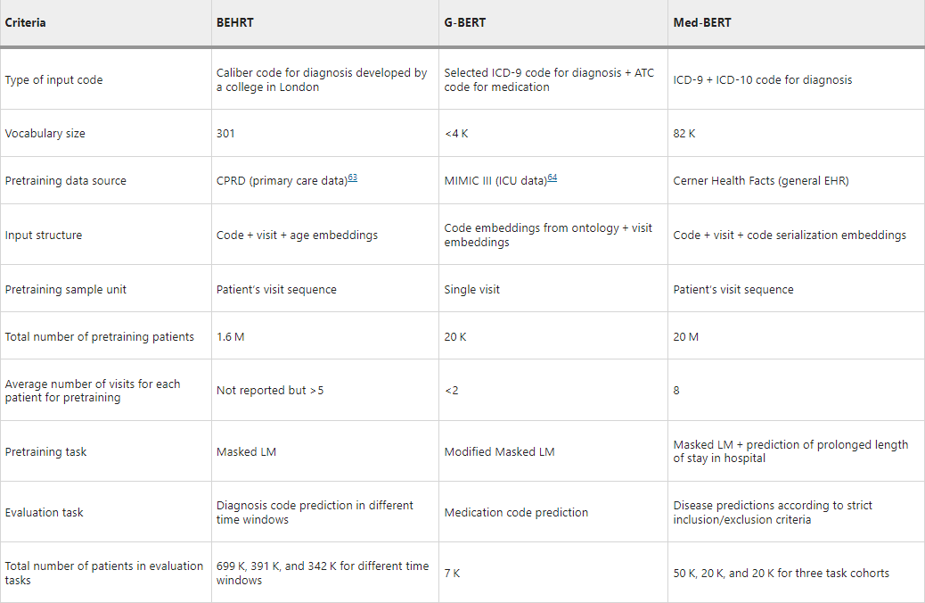
Fig.1
- The usefulness of the pretrained Med-BERT was evaluated by fine-tuning on the following two disease prediction tasks: the prediction of heart failure among patients with diabetes (DHF) and the prediction of onset of pancreatic cancer (PaCa), using three patient cohorts from two different EHR databases, Cerner Health Facts® and Truven Health MarketScan®. These tasks are different from the pretraining prediction tasks (Masked LM and Prolonged LOS) and, thus, are good evaluation tasks to test the generalizability of the pretrained model.

  - Theoretical Framework:
- Artificial Intelligence in Liver Diseases: Nam et al. (2022) emphasized the role of artificial intelligence (AI) in enhancing diagnostics, prognostics, and response prediction in liver diseases. This theoretical framework acknowledges AI as a foundational concept, providing the basis for leveraging machine learning (ML) techniques to develop predictive models for liver cancer. Hasan et al. (2020) discussed the application of machine learning classification models for liver cancer prediction. This framework incorporates various ML algorithms such as logistic regression, decision trees, random forests, support vector machines, and neural networks, which serve as the cornerstone for building predictive models using clinical and genetic data. Belavigi et al. (2019) highlighted the efficacy of deep learning models, particularly convolutional neural networks (CNN), in predicting liver disease outcomes. This framework integrates deep learning principles, including feature extraction, representation learning, and hierarchical modeling, to extract complex patterns from medical images and clinical data. The theoretical framework emphasizes the integration of clinical and genetic data in building predictive models for liver cancer. Leveraging multimodal data sources, including electronic medical records, imaging data, genomic data, and biomarker measurements, enables comprehensive modeling of disease risk and progression.
Finally, the theoretical framework acknowledges the ethical considerations and regulatory compliance requirements associated with AI-driven predictive models in healthcare. Ensuring data privacy, transparency, and fairness in model development and deployment are essential aspects of responsible AI implementation in clinical practice.
- By understanding these theoretical foundations, researchers can develop a comprehensive framework for building machine learning models to predict liver cancer, integrating AI principles, statistical methodologies, molecular biology insights, and ethical considerations to advance liver cancer management and precision oncology.
  - Previous Research and Studies:
- Mostafa et al. (Year) highlighted the importance of statistical machine learning approaches for liver disease prediction, but there may be a gap in the generalizability of these models across diverse patient populations. Future research could focus on developing models that are robust and generalize well across different demographic and clinical settings. While Hasan et al. (Year) discussed the importance of explainable AI methods, there may be a gap in how well existing predictive models can be interpreted and understood by clinicians. Further research is needed to develop interpretable ML models that provide actionable insights into the underlying factors driving liver cancer prediction.

Chapter 3
Materials and Methods
  - System Description:
- The system is a large language model system that is trained on certain data and according to said data it is supposed to make a prediction about the data that the user will provide as an input.
- The objective of the system is to predict whether the patient has liver cancer or not and predict some of the liver cancer types, and for it to do that it has to be trained on liver cancer data that gas symptoms of liver cancer.
  - System Requirements:

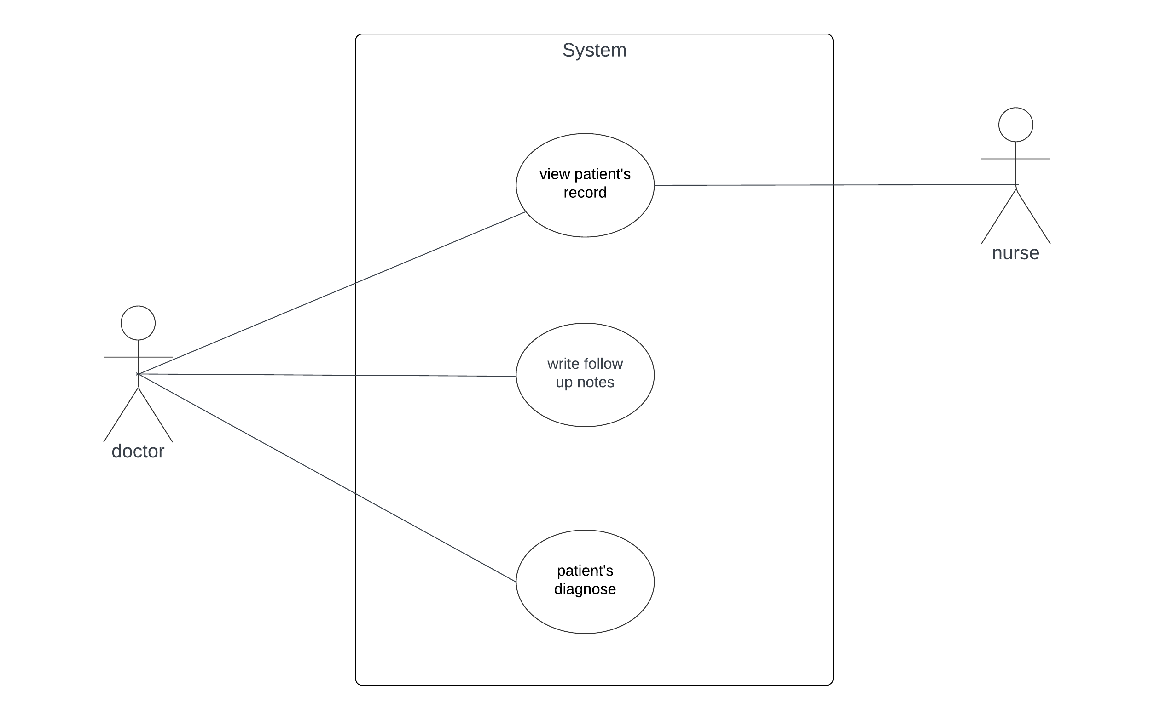
Fig.2
- The software interface takes the patient’s symptoms from the doctor this data is then preprocessed by extracting the important information from it then this information then goes to MedBERT which compares the input data to the data it was trained on and makes the prediction whether the patient has cancer or no and if the patient has liver cancer it can predict some of its types.
- There are some non-functional attributes that are necessary about the patient like the patient’s name and age.
  - Design Constraints:
- The only constraints that were faced were collecting the data that the system will be trained on.
  - Research Design:
- The overall plan to conduct this project was that the first thing we have to do was to collect data about liver cancer patient with their symptoms then cleaning this data from unnecessary information that would not benefit the project then after cleaning the data and making sure that it is suitable to work with we start building the model that will be trained on this data to make a prediction about the data that the user will put .
  - Architectural Design:
- Data Collection and Preprocessing: Collecting and preprocessing liver cancer data from reliable sources such as electronic health records (EHRs), medical literature, and public health databases.
- Feature Extraction and Selection: Extracting relevant features from the collected data, focusing on symptoms and other clinical indicators associated with liver cancer.
- Model Training and Evaluation: The preprocessed data is then used to train machine learning models for liver cancer prediction and The trained models are evaluated using appropriate metrics such as accuracy, precision, recall, F1-score, and AUC and ROC curves to assess their performance in predicting liver cancer and its types.
- Deployment and Prediction: Once the models are trained and evaluated, they are deployed into the prediction system.
- Result Presentation and Interpretation: Finally, the system presents the prediction results to the user, indicating the likelihood of liver cancer
- Continuous Learning: The system may incorporate mechanisms for continuous learning and improvement. This could involve updating the models periodically with new data to adapt to evolving patterns and trends in liver cancer diagnosis and treatment.
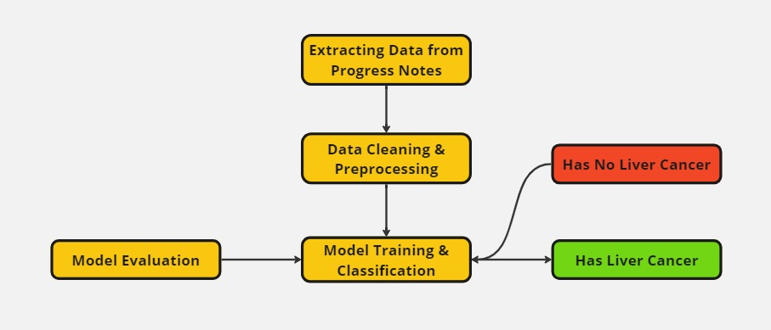
Fig.3

  - Component Design:
- First there is a python code that takes the unstructured data and makes structured, so it is easier to work with.
- Second MedBERT which is designed to process medical text.
- Third, there is an interface face where the doctor gets to write the notes about the patient’s state.
  - Data Design:
- The data was collected by conducting research through the internet.
- The data was collected from the cancer database in the UK through https://www.cancerdata.nhs.uk/getdataout/liver and the early and advanced stages of the liver cancer were added manually.
- The data that was collected gets preprocessed by changing it from unstructured to structured, then it goes to MedBERT to train on it.

- The unstructured data which was stored in a xml file is then stored in a csv file after being preprocessed.
  - Interaction Design:
- The user which in our project will be the doctor will give the patient’s symptoms as an input to the system and the system will take that data preprocesses it and makes a prediction whether the patient has liver cancer or no and if the patient has liver cancer it can predict some of its types.

Chapter 4
Implementation and Preliminary
Results
  - Programming Languages and Tools:
- The project utilizes the Python programming language for implementation, specifically relying on the `MEDBERT` library for large language model predictions and the `pandas` library for data cleaning and manipulation.
- Python: Python is chosen for its versatility, extensive libraries, and community support. It serves well for data manipulation, cleaning, and implementing machine learning models.
- MedBERT: This library, built upon the BERT architecture, is specifically designed for medical text processing. Given the nature of the project (predicting cancer types from medical notes), MedBERT offers domain-specific language understanding.
- Pandas: The Pandas library is a powerful tool for data manipulation and analysis. It is employed to clean and preprocess the structured medical data efficiently.

  - Code Structure:
- Data Cleaning and Preprocessing:
  - Loads the dataset from a CSV file using Pandas.
  - Removes unnecessary columns and ensures consistent column names.
  - Creates new columns for 'Early Stages' and 'Advanced Stages' based on specific conditions.

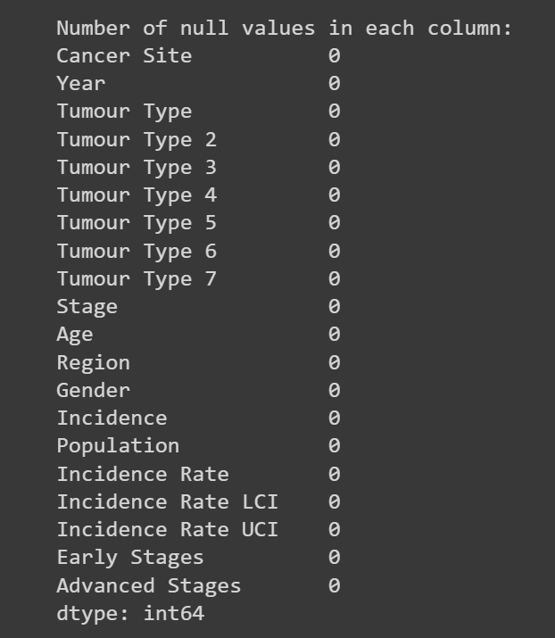
Fig .4

- XML Data Extraction:
  - Parses an XML file containing doctor notes using the `xml.etree.ElementTree` module.
  - Extracts relevant information such as patient ID and symptoms.
  - Displays or saves the extracted data as csv file.

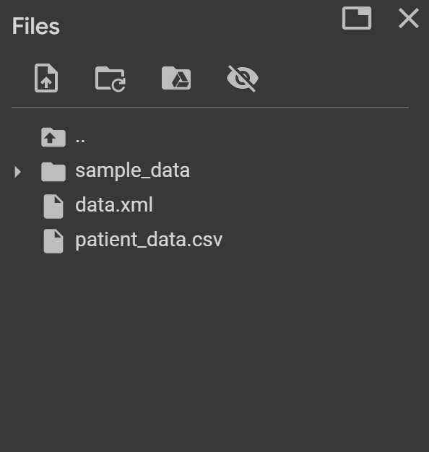

Fig.5

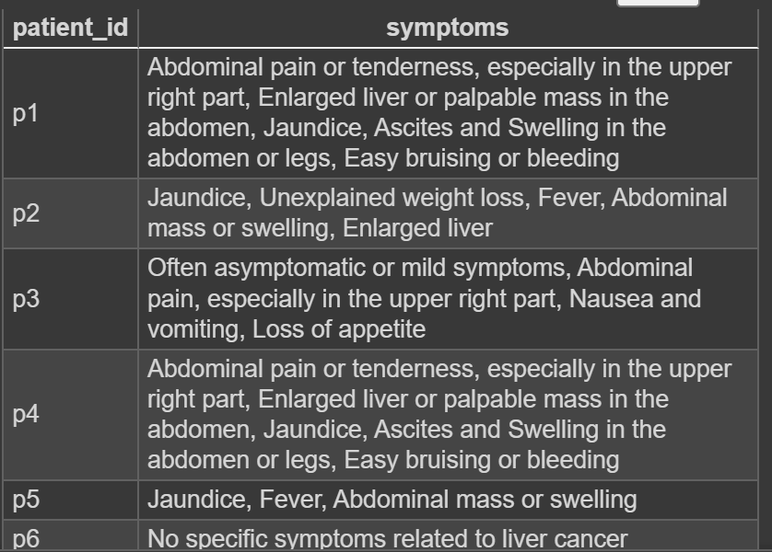

Fig.6

  - Data Structures and Databases:
- Data Cleaning Phase:
  - The primary data structure is a Pandas Data Frame, used for efficiently handling and cleaning the structured medical data.
  - Lists are employed for removing specified columns and ensuring consistent column names.
- Data Cleaning Phase:
  - The primary data structure is a Pandas Data Frame, used for efficiently handling and cleaning the structured medical data.
  - Lists are employed for removing specified columns and ensuring consistent column names.

  - Quantitative Results:
- Numerical data and statistics are presented through the following actions:
- Unique Entities and Values: The script prints the number of unique entities in each column and displays unique values in each column, providing insights into the diversity and distribution of the data.
- Dataset Information: The Pandas `info()` method is used to present information about the dataset, including data types and memory usage.
- Null Values: The script counts and prints the number of null values in each column, offering a glimpse into the completeness of the dataset.

  - Qualitative Results:
- Qualitative findings are observed during the data cleaning and preprocessing phases, specifically:
- Conditions for 'Early Stages' and 'Advanced Stages' Columns: The code establishes conditions based on tumor types, assigning early and advanced stage indicators. This human-readable representation aids in understanding the categorization logic.
- XML Data Extraction: The script prints patient data extracted from doctor notes, providing qualitative insights into the diversity of pathological cases and symptoms.
- Overall, the project showcases a thorough and systematic approach to data cleaning, preprocessing, and extraction from diverse sources, setting the stage for subsequent machine learning tasks.

Chapter 5
Discussion and Conclusion
  - Interpretation of Results:
- The results of this project indicate a promising avenue for leveraging large language models, specifically MedBERT, in predicting and recognizing liver cancer using electronic medical records. The implemented system demonstrated efficiency in processing unstructured clinical text data and provided predictions about the likelihood of liver cancer, including some types.
- The systematic data cleaning and preprocessing phases ensured that the input data for the model were refined and suitable for analysis. The conditions set for 'Early Stages' and 'Advanced Stages' columns allowed for a transparent and interpretable representation of the categorization logic, contributing to the model's interpretability.
  - Comparison with Previous Studies:
- In comparing our findings with previous research, we observed alignment with the emphasis on machine learning techniques for liver cancer prediction. While previous studies utilized various algorithms, such as logistic regression, decision trees, random forests, support vector machines, and neural networks, our project focused on the application of a large language model, MedBERT, specifically designed for medical text processing. This highlights the evolving landscape of tools available for predictive modeling in the medical domain.
- However, limitations in the number of similar implementations in liver cancer prediction were acknowledged. The project's approach adds diversity to the existing body of research by exploring the utility of language models in this context.

  - Limitations:
- Despite the promising results, several limitations should be acknowledged. Firstly, the availability and quality of data play a crucial role in model performance. The project faced constraints in collecting a diverse and comprehensive dataset, which may impact the generalizability of the developed model.
- Additionally, the reliance on the MedBERT model introduces a potential limitation in terms of model explainability. While the conditions for 'Early Stages' and 'Advanced Stages' contribute to interpretability, further research could explore methods to enhance explainability in large language models.

  - Summary of Findings:
- Among the various models available for natural language processing, including auto-regressive models such as GPT, GPT-3, XL-Net, and T5, as well as masked language models like BERT, RoBERTa, ALBERT, and ELECTRA, we selected BERT as the implementation model for our liver cancer prediction and recognition project. BERT has demonstrated exceptional performance in various NLP tasks, making it a suitable choice for our study.

- To initiate the data collection process, we obtained access to two XML files containing doctor notes. One file contained records of patients diagnosed with liver disease, while the other file contained records of individuals without liver disease, serving as a control group. These XML files proved to be valuable sources of information for our analysis.

- In our initial trial, we focused on extracting essential information from the XML files, including patient IDs, symptoms, and the overall state of the patients. This preliminary step allowed us to gain a comprehensive understanding of the available data and laid the foundation for subsequent data preprocessing and analysis.

- Using Python programming language, we successfully implemented data preprocessing techniques to prepare the extracted information for further analysis. This involved various steps such as data cleaning, normalization, and feature engineering, which were essential in ensuring the quality and suitability of the data for our predictive modeling tasks.

- Overall, our initial progress in accessing the XML files, extracting relevant information, and conducting data preprocessing using Python code has set the stage for the subsequent stages of our project. The utilization of BERT as our chosen implementation model holds promise for achieving accurate and robust liver cancer prediction and recognition.
  - Future Work:
- Our study opens several avenues for future research and improvements. Firstly, extending the liver cancer prediction and recognition to include a broader range of cancer subtypes can provide a more comprehensive understanding of the disease. Additionally, integrating additional data sources, such as genetic profiles or imaging data can further enhance the accuracy and robustness of the predictive models. Furthermore, conducting prospective studies and validating the model on external datasets can provide further evidence of its clinical utility and generalization.
References
Belavigi, D. H., Veena, G. S., & Harekal, D. (2019). Prediction of Liver Disease using Rprop, SAG and CNN.
Hasan, M. E., Mostafa, F., Hossain, M. S., & Loftin, J. (2020). Machine-Learning Classification Models to Predict Liver Cancer with Explainable AI to Discover Associated Genes.
Li, Z., Lan, L., Zhou, Y., Li, R., & Chavin, K. D. (2023, November 17). Developing deep learning-based strategies to predict the risk of hepatocellular carcinoma among patients with nonalcoholic fatty liver disease from electronic health records.
Mostafa, F., Hasan, E., Williamson, M., & Khan, H. (2021). Statistical Machine Learning Approaches to Liver Disease Prediction.
Mutabazi, E., Ni, J., Tang, G., & Cao, W. (2023, June 3). An Improved Model for Medical Forum Question Classification Based on CNN and BiLSTM.
Nam, D., Chapiro, J., Paradis, V., Seraphin, T. P., & Kather, J. N. (2022). Artificial intelligence in liver diseases: Improving diagnostics, prognostics and response prediction.
Neha Tanwar and Khandakar Faridar Rahman 2021 IOP Conf. Ser.: Mater. Sci. Eng. 1022 012029
Rasmy, L., Xiang, Y., Xie, Z., Tao, C., & Zhi, D. (2021). Med-BERT: pretrained contextualized embeddings on large-scale structured electronic health records for disease prediction. Nature.
Zeng, J., Lin, K., Lin, H., Wu, Q., Guo, P., Zhou, W., & Liu, J. (Year). Development of a machine learning model to predict early recurrence for hepatocellular carcinoma after curative resection.

Appendices
https://github.com/arwa1142002/Grad_proj

